**Name: Varun Agarwal**

**Registration Number: 16BEC0450**

**ECE3003- Microcontroller and its Applications**

**Lab Slot: L37+L38**

**Prof. Chitra P**

**TASK II**

**Program 1**

Write an 8051 ALP for the following

**55H AND AAH**

**Code:**

ORG 0000H

XX:MOV A,#55H

ANL A,#0AAH

MOV 07H,A

SJMP XX

END

**OUTPUT :**

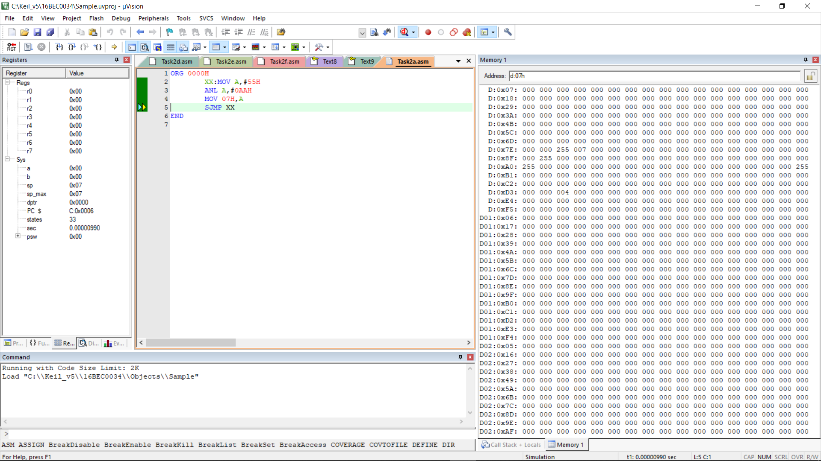

**55H OR AAH**

**Code:**

ORG 0000H

YY: MOV A,#55H

ORL A,#0AAH

MOV 07H,A

SJMP YY

END

**OUTPUT:**

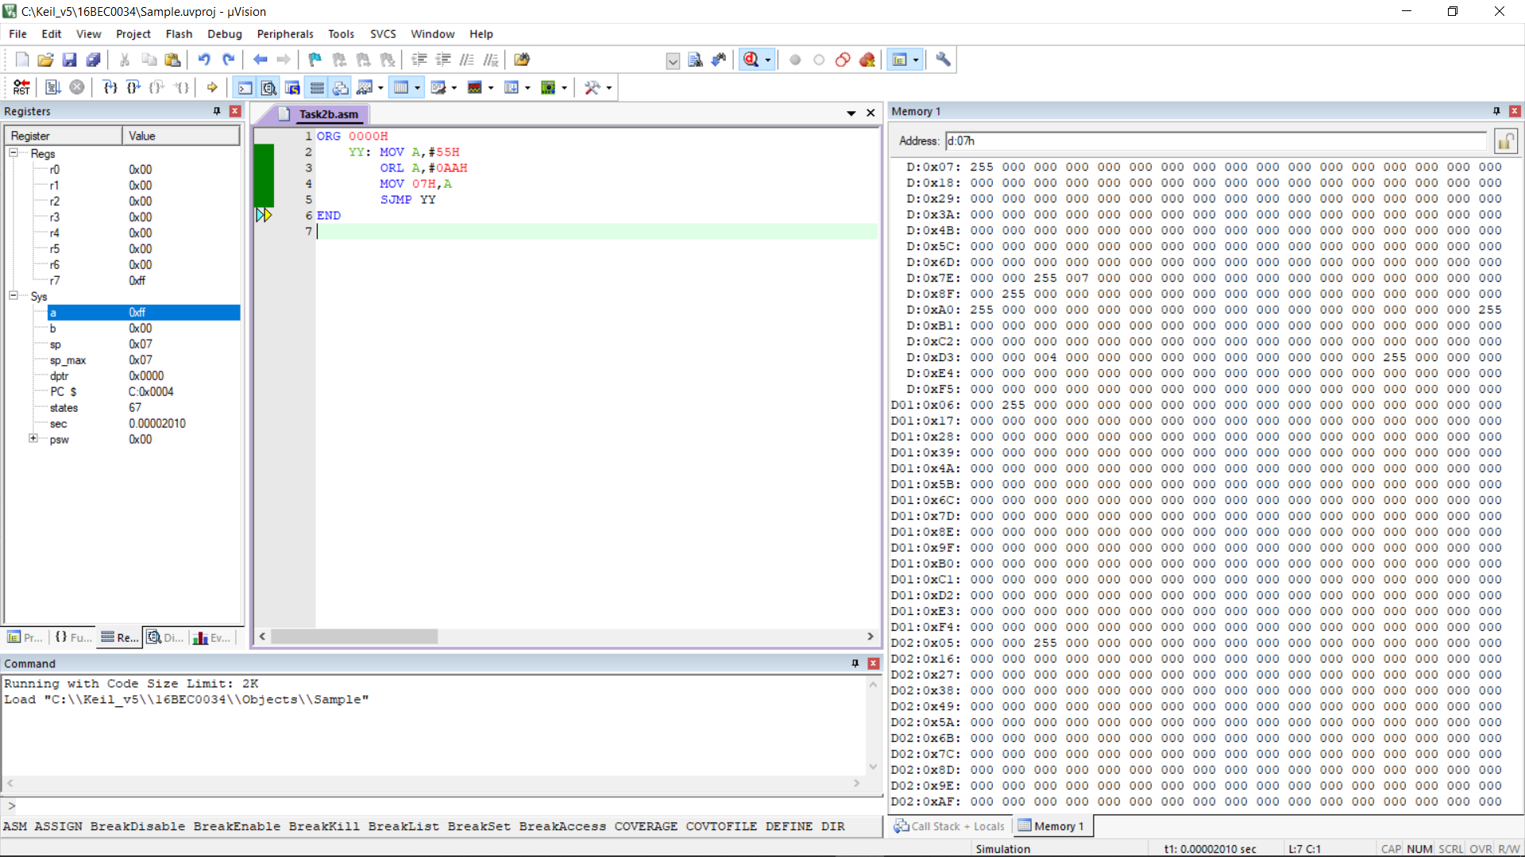

**55H XOR AAH**

**Code**:

ORG 0000H

MOV A,#55H

CPL A

ANL A,#0AAH

MOV 07H,A

CLR A

MOV A,#0AAH

CPL A

ANL A,#55H

ORL A,07H

MOV 09H,A

END

**OUTPUT:**

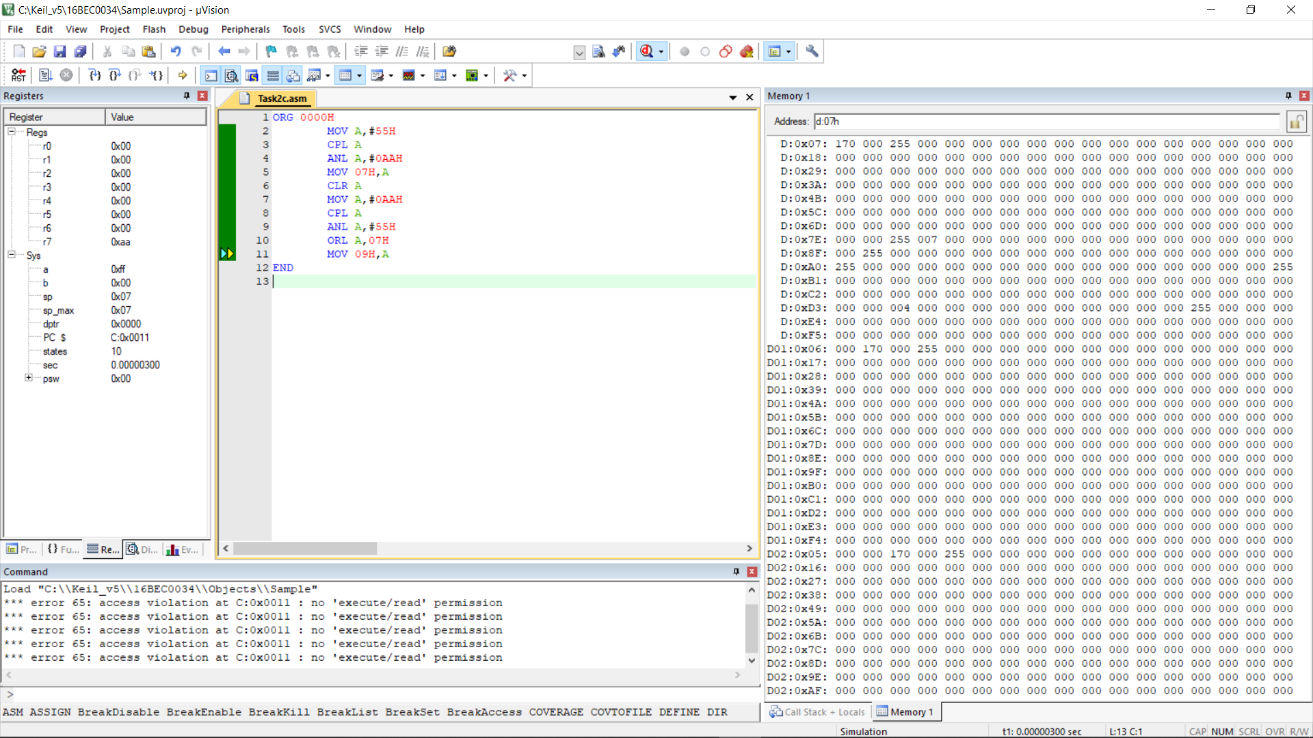

**Program 2**

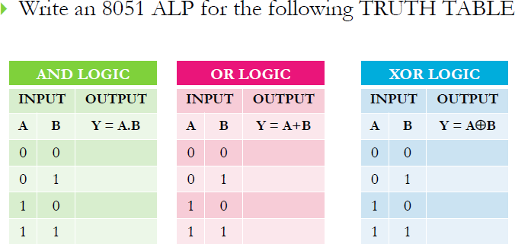

**AND Logic**

**Code & Output**:

ORG 0000H

SETB P1.0

SETB P1.1

CLR P2.0

XX: MOV C,P1.0

ANL C,P1.1

MOV 07H,C

MOV P2.0,C

SJMP XX

END

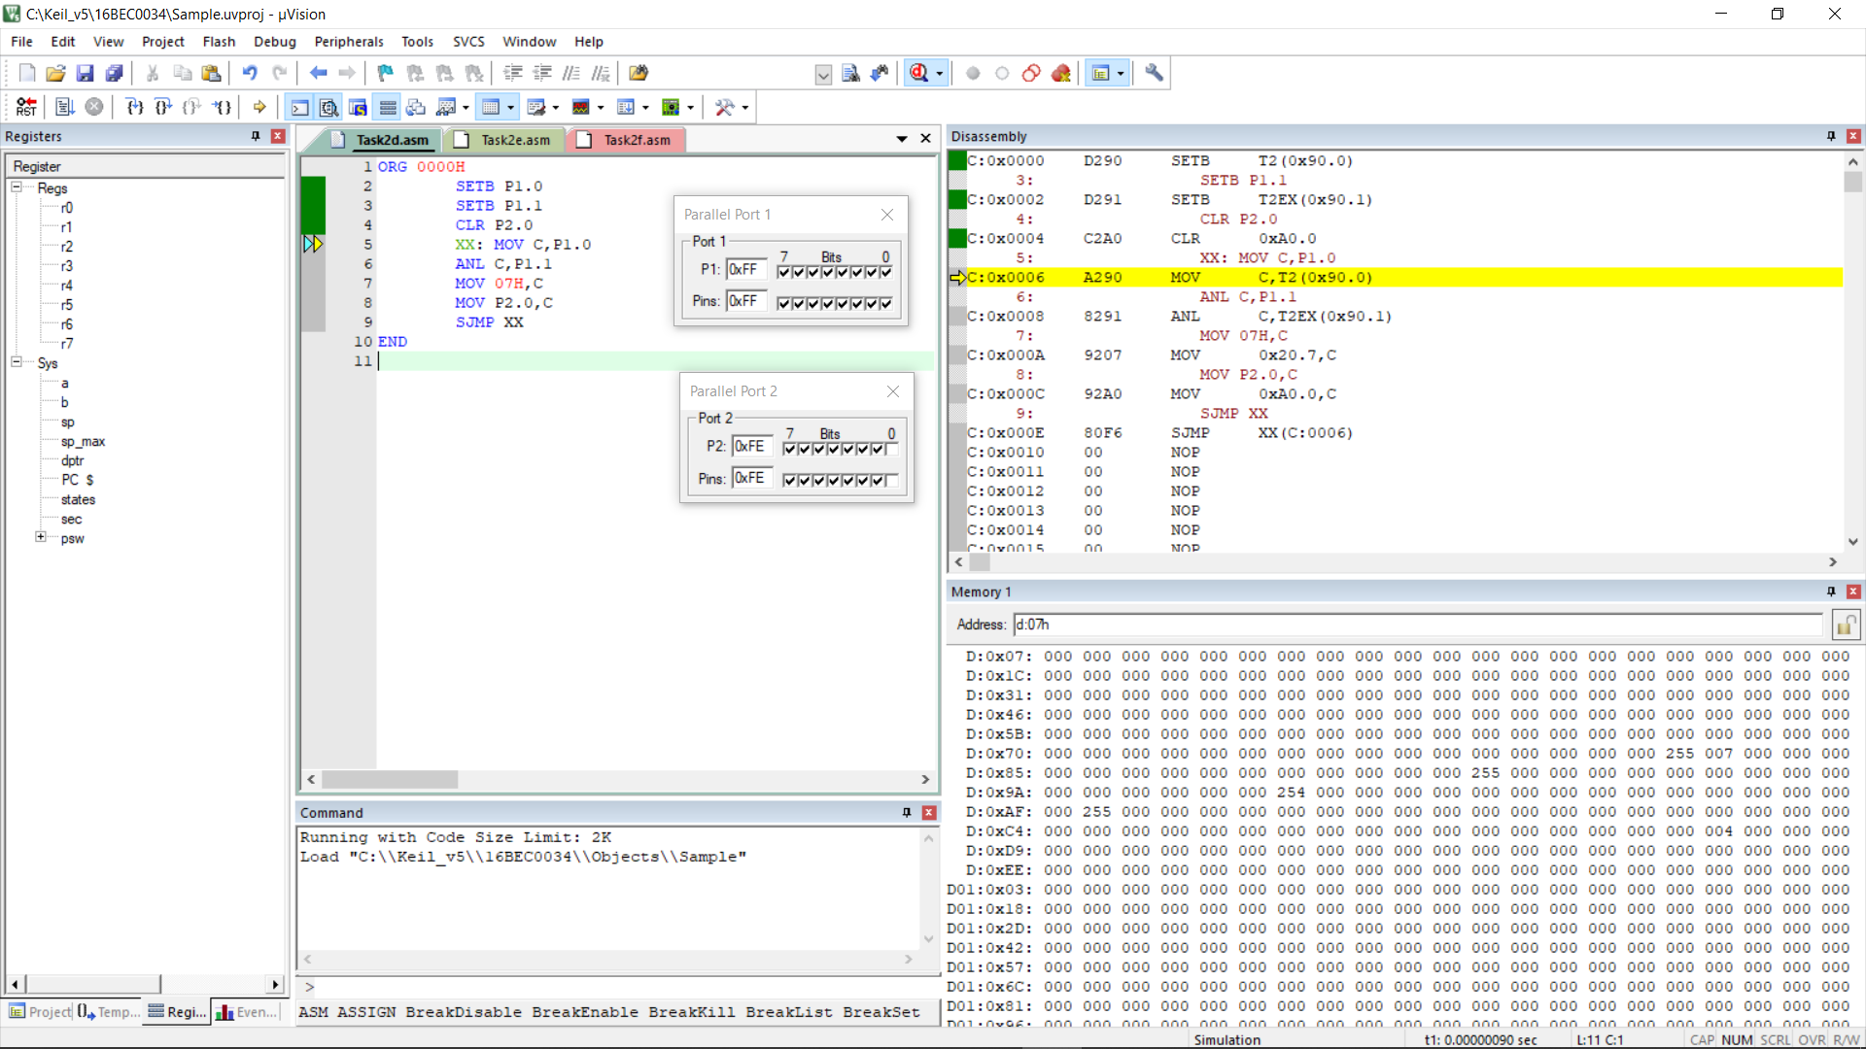

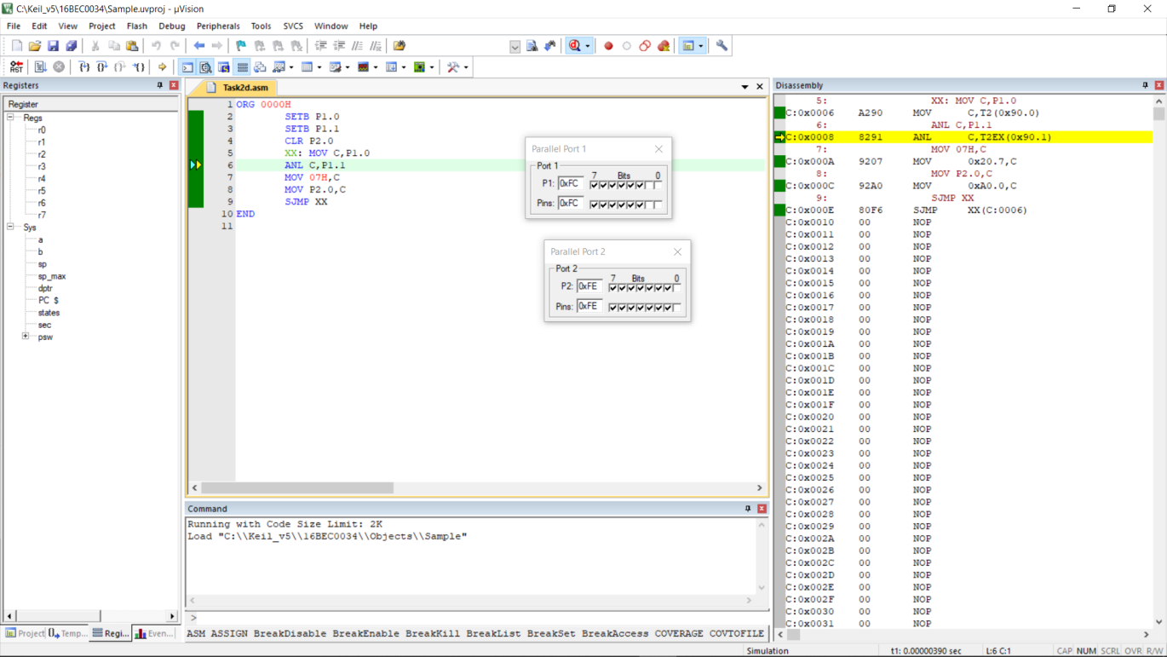

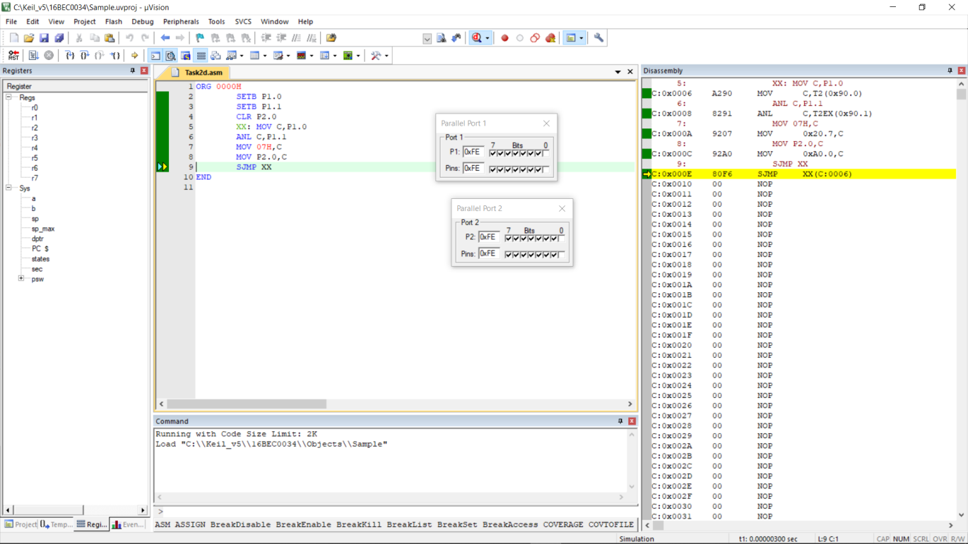

**OR Logic**

**Code:**

ORG 0000H

SETB P1.0

SETB P1.1

CLR P2.0

XX: MOV C,P1.0

ORL C,P1.1

MOV 07H,C

MOV P2.0,C

SJMP XX

END

**OUTPUT:**

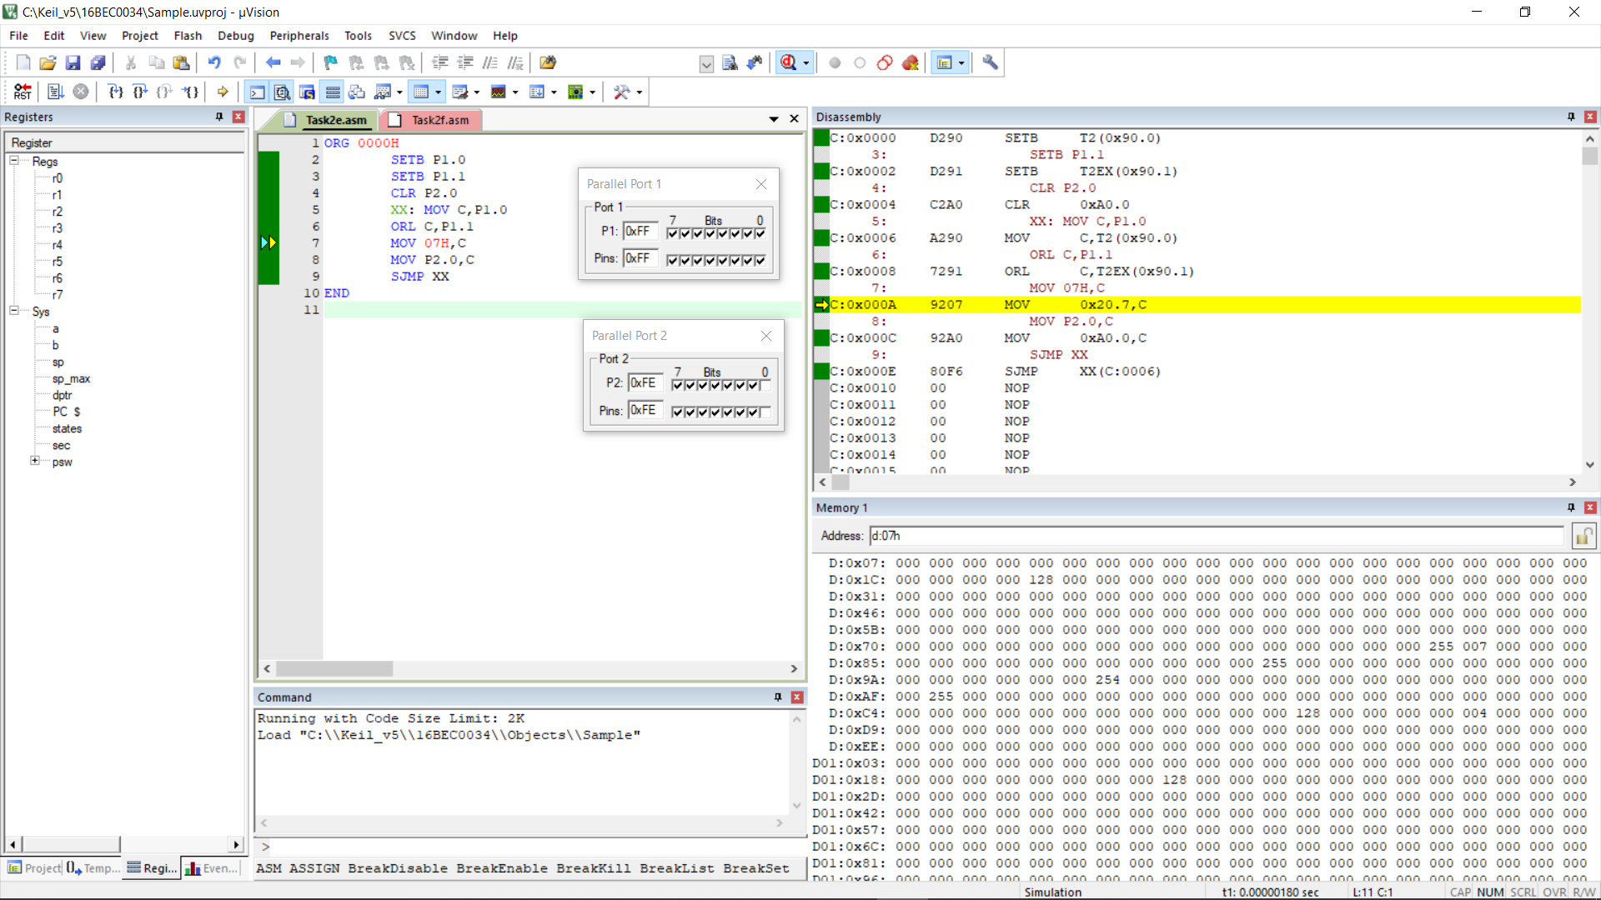

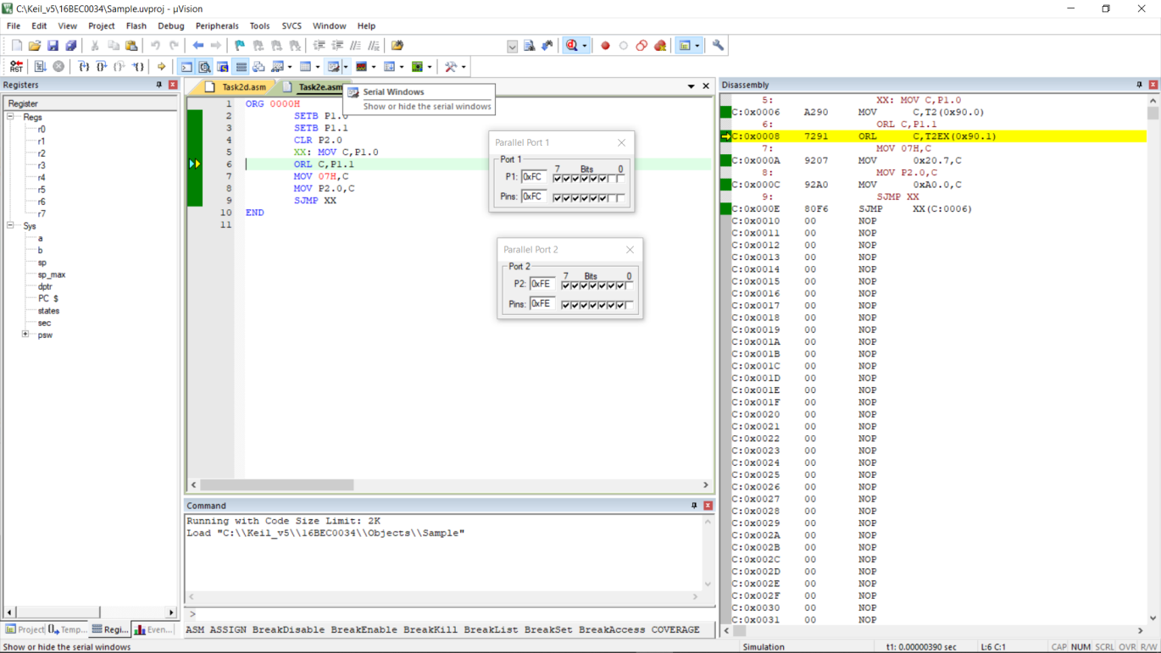

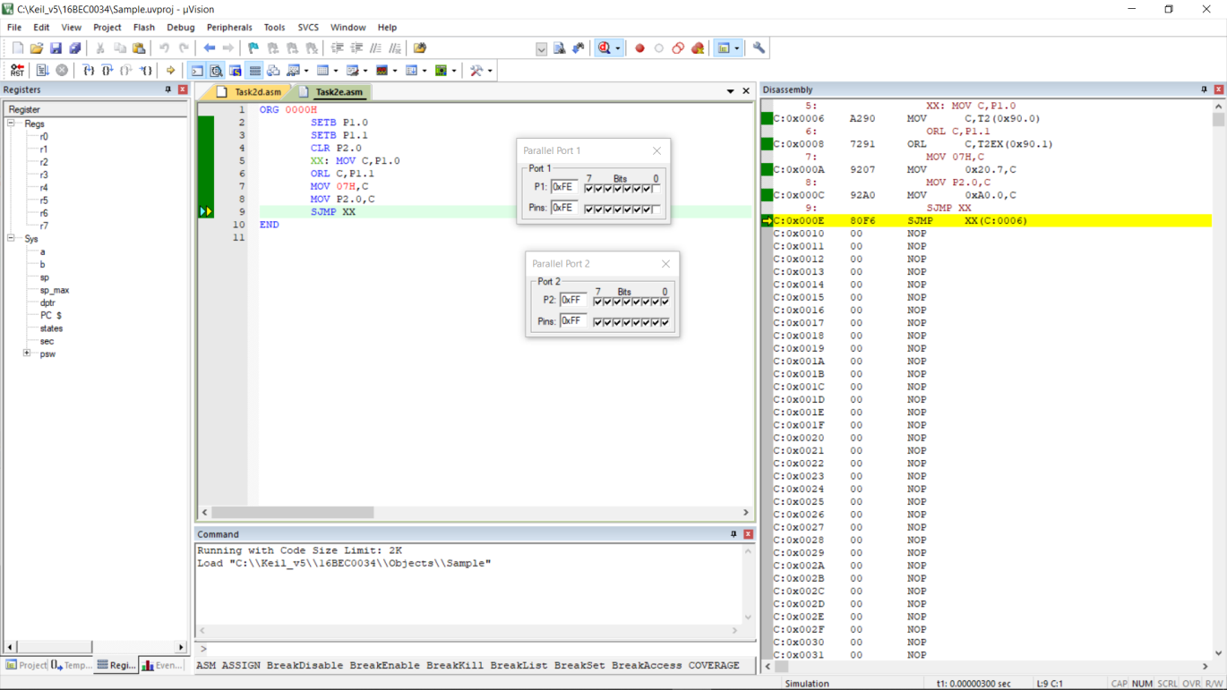

**XOR Logic**

**Code :**

ORG 0000H

SETB P0.0

SETB P0.1

CLR P1.0

XX: MOV C,P0.0

CPL C

ANL C,P0.1

MOV 09H,C

MOV C,P0.1

CPL C

ANL C,P0.0

ORL C,09H

MOV P1.0,C

SJMP XX

END

**OUTPUT :**

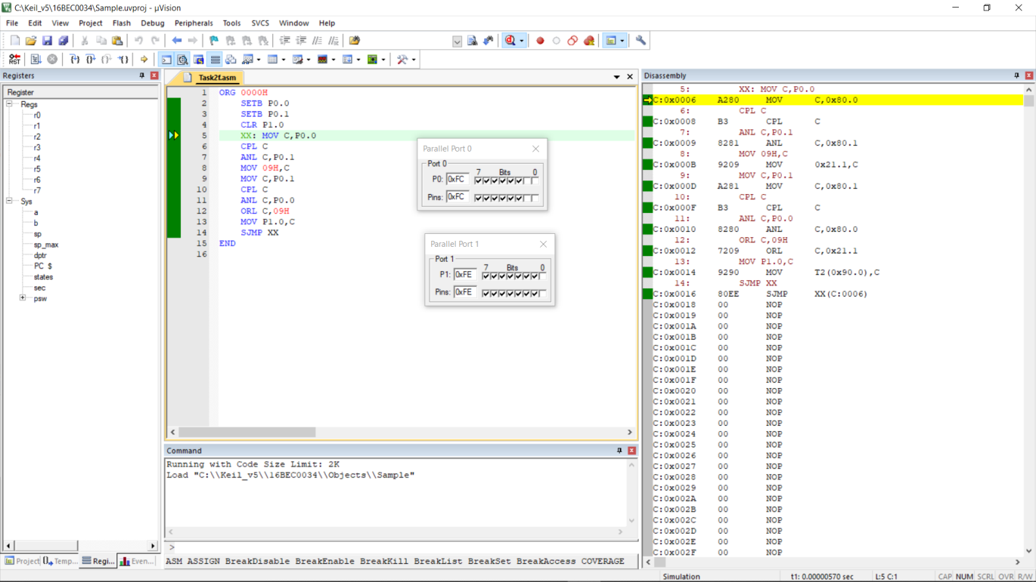

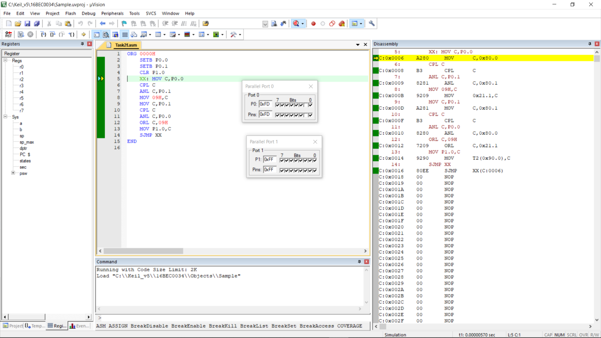

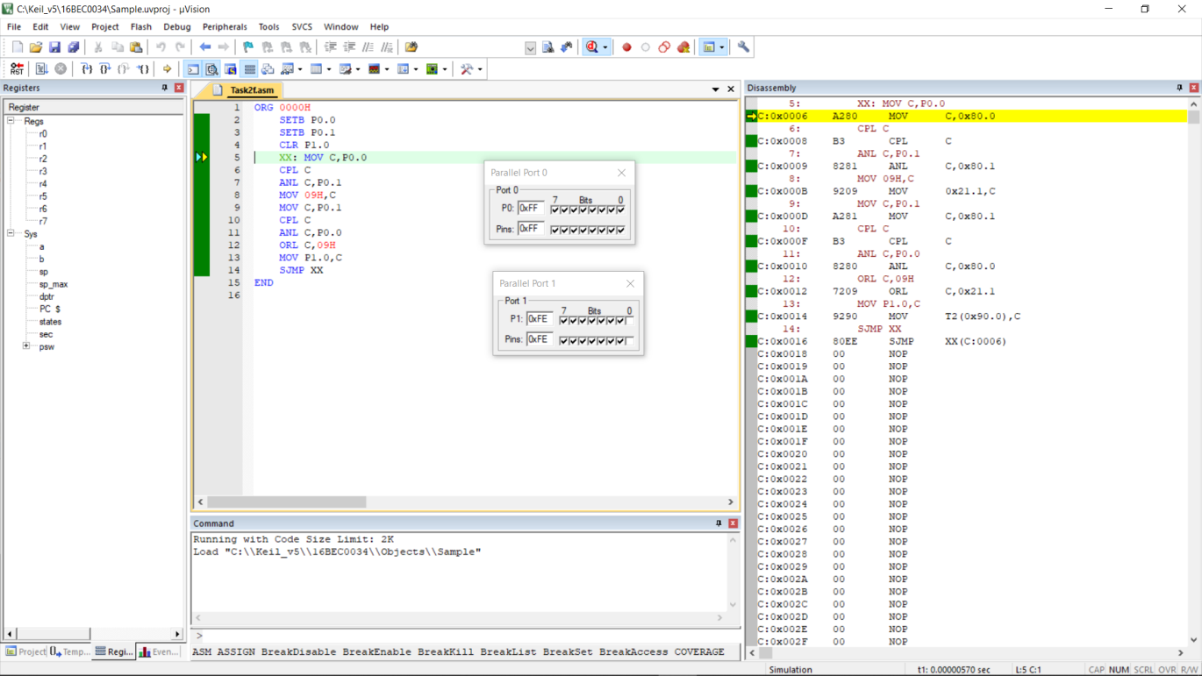

Draw the truth table for the following circuits and verify the same by writing the 8051 ALP using Keil IDE.

**Program 2A**

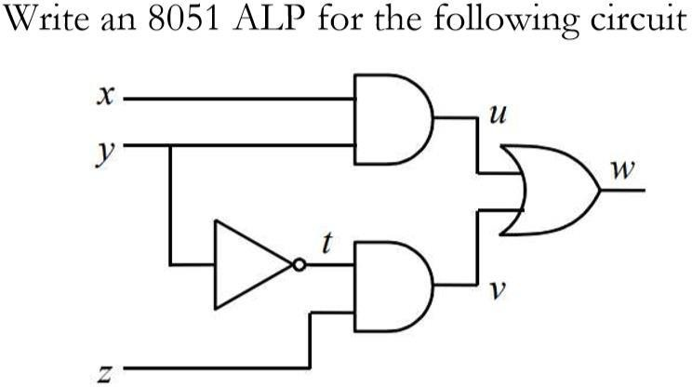

The reduced expression of this logic circuit diagram is:



Also







Assume ‘x’, ‘y’ and ‘z’ to be stored in port 0 bits P0.0, P0.1 and P0.2 respectively. And the outputs ‘u’, ‘t’, ‘v’ and ‘w’ in port 1 bits P1.0, P1.1, P1.2 and P1.3 respectively. So the output screenshot and code for the expression will be :

**Code** :

ORG 0000H

SETB P0.0

SETB P0.1

SETB P0.2

CLR P1.0

CLR P1.1

CLR P1.2

CLR P1.3

XX: MOV C,P0.0

ANL C,P0.1

MOV P1.0,C

CLR C

MOV C,P0.1

CPL C

MOV P1.1,C

ANL C,P0.2

MOV P1.2,C

ORL C,P1.0

MOV P1.3,C

SJMP XX

END

**OUTPUT:**

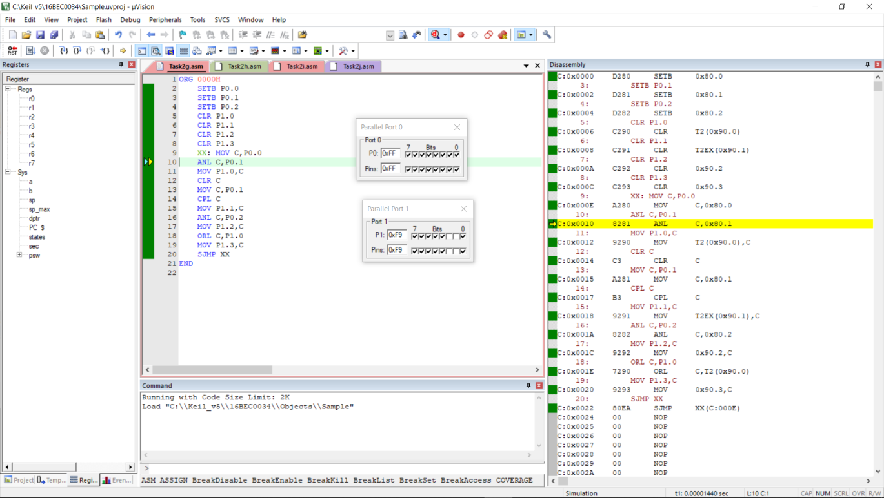

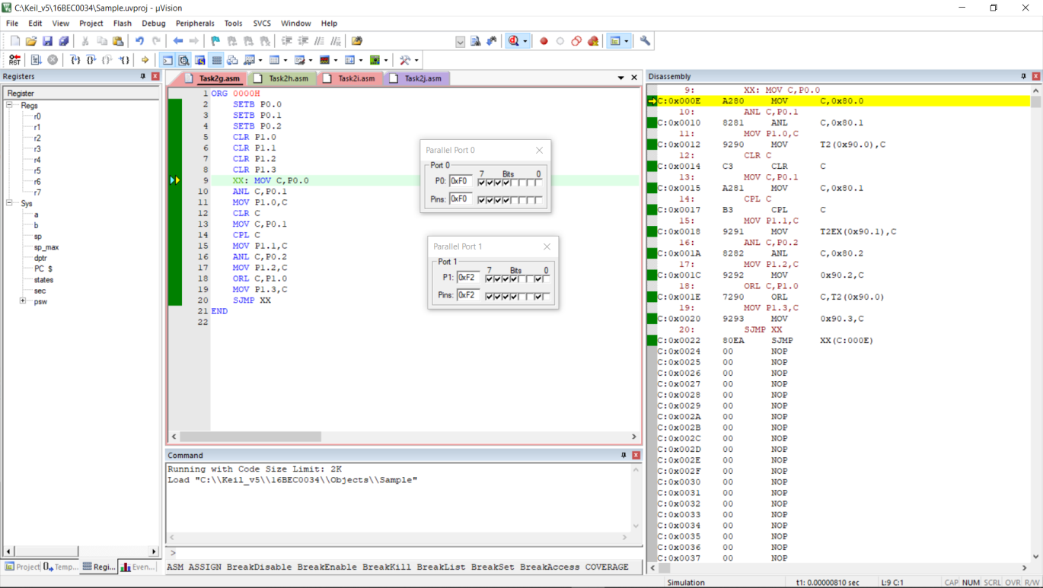

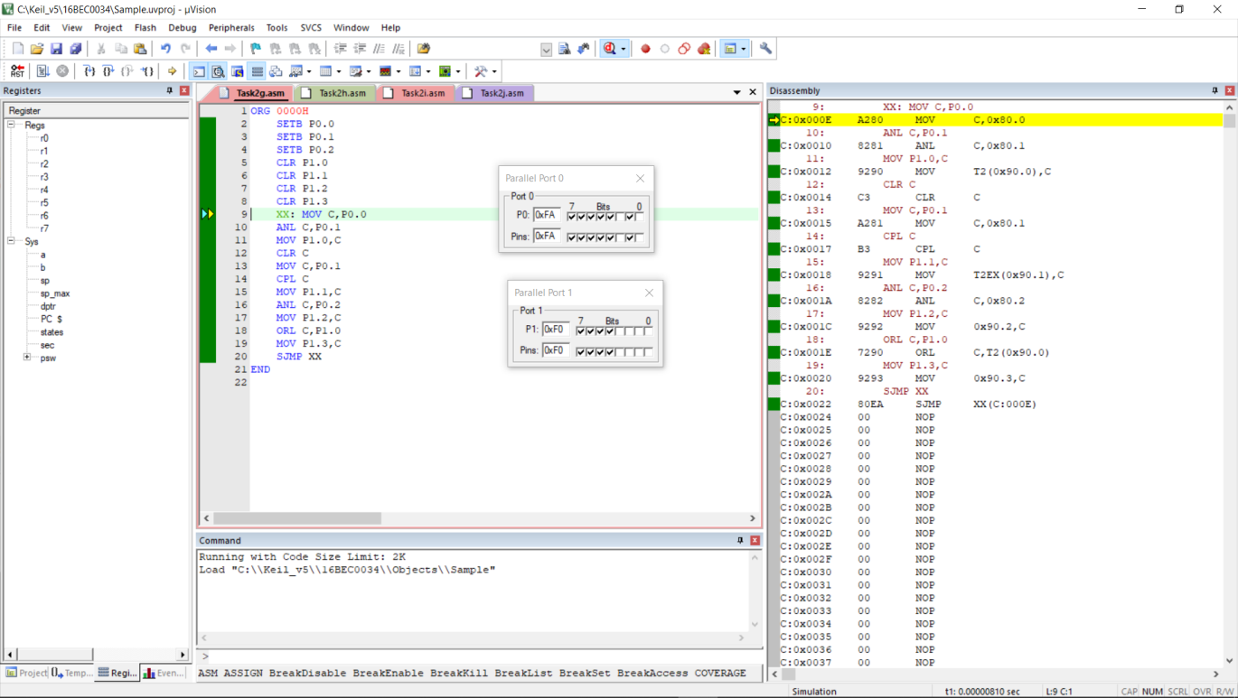

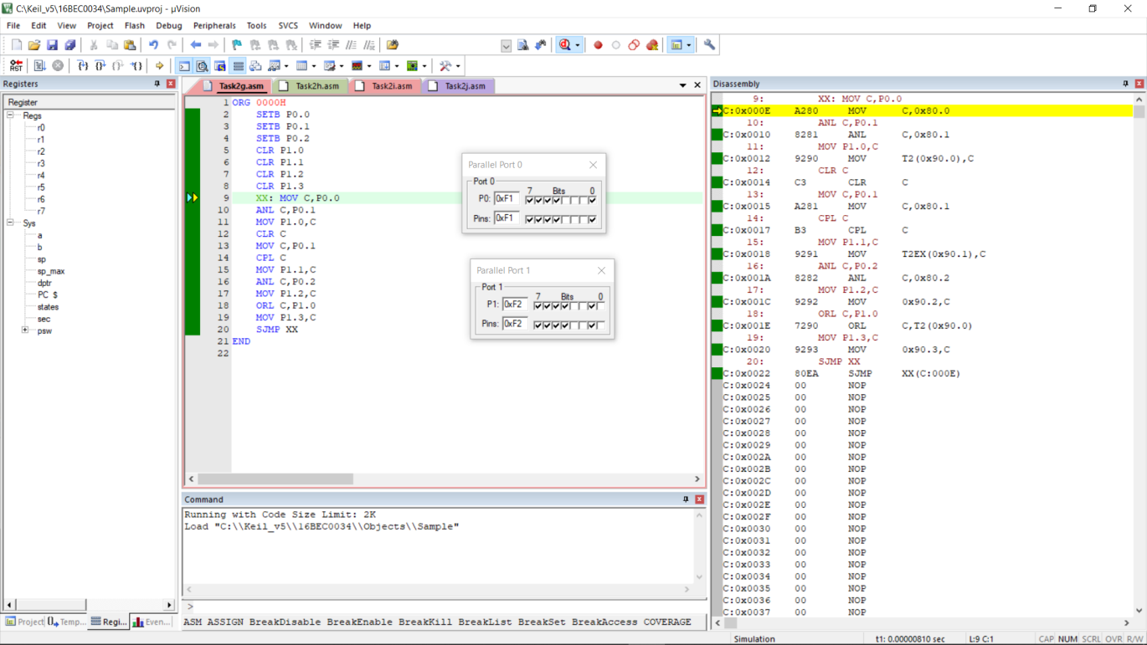

**Program 2b**

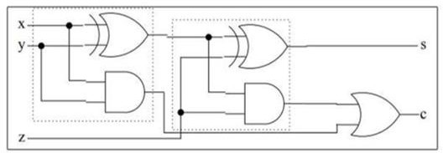

The reduced expression of this logic circuit diagram is: (Full adder)





Let us assume ‘x’, ‘y’ and ‘z’ to be stored in port 0 bits P0.0, P0.1 and P0.2 respectively. And the outputs ‘s’ and ‘c’ in port 1 bits P1.0, P1.1 respectively. So the output screenshot and code for the expression will be:

**Code & Output**:

ORG 0000H

SETB P0.0

SETB P0.1

SETB P0.2

CLR P1.0

CLR P1.1

XX: MOV C,P0.0

CPL C

ANL C,P0.1

MOV 07H,C

CLR C

MOV C,P0.1

CPL C

ANL C,P0.0

ORL C,07H

MOV 08H,C

CLR C

MOV C,P0.2

CPL C

ANL C,08H

MOV 09H,C

CLR C

MOV C,08H

CPL C

ANL C,P0.2

ORL C,09H

MOV P1.0,C

CLR C

MOV C,P0.0

ANL C,P0.1

MOV 0AH,C

CLR C

MOV C,P0.0

CPL C

ANL C,P0.1

MOV 0BH,C

CLR C

MOV C,P0.1

CPL C

ANL C,P0.0

ORL C,0BH

ANL C,P0.2

ORL C,0AH

MOV P1.1,C

SJMP XX

END

**1. x=0;y=0;z=0 so s=0 and c=0**

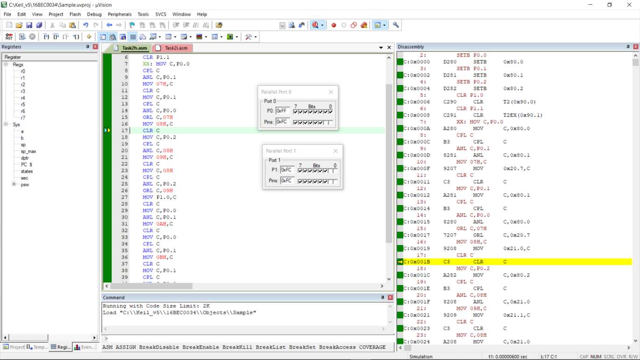

**2. x=0;y=0;z=1 so s=1 and c=0**

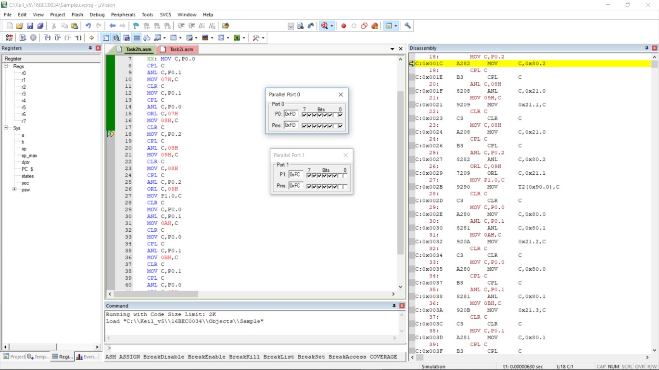

**3. x=0;y=1;z=0 so s=1 and c=0**

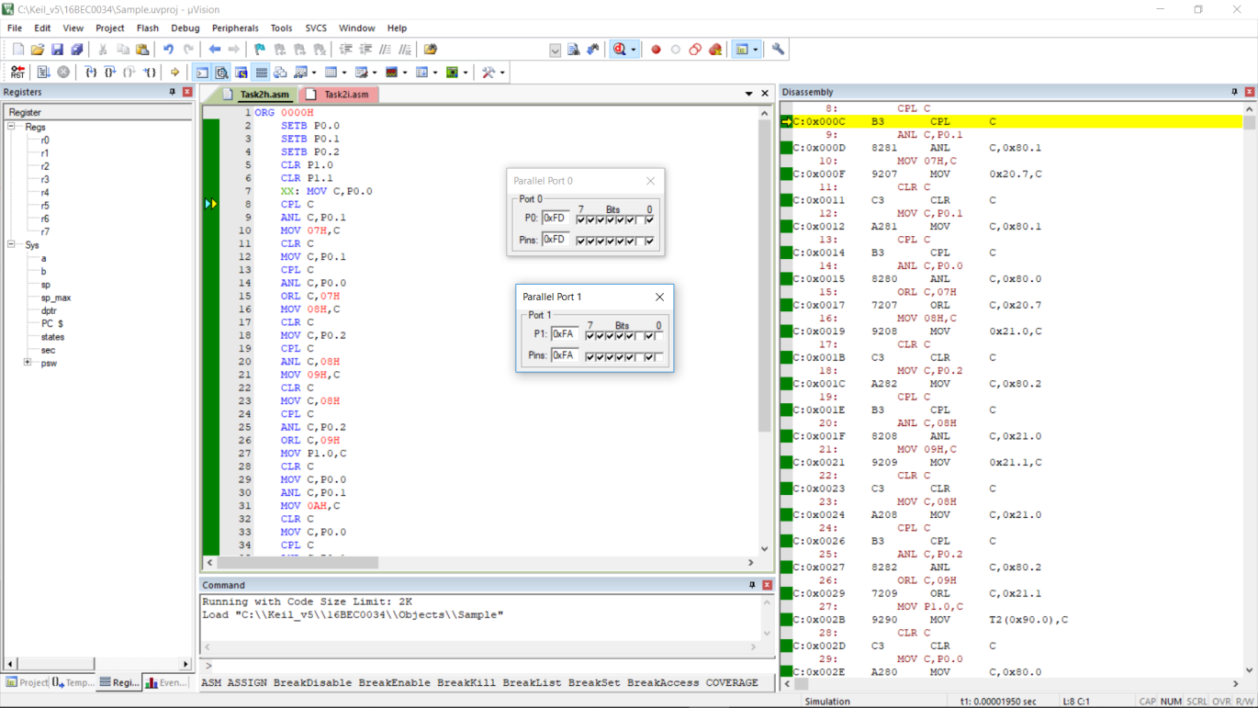

**4. x=0;y=1;z=1 so s=0 and c=1**

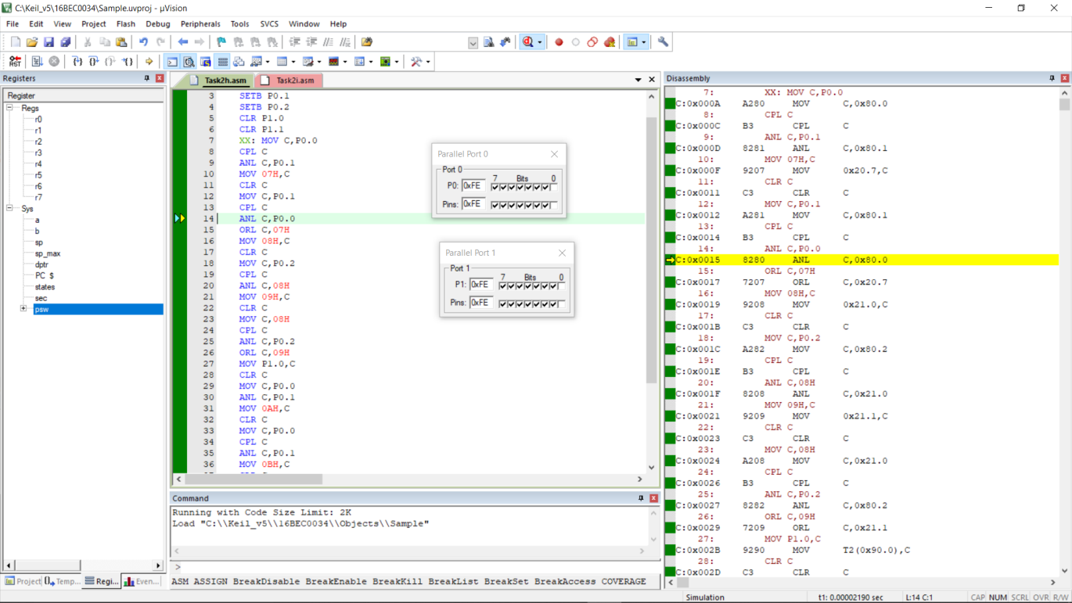

**5. x=1;y=0;z=0 so s=1 and c=0**

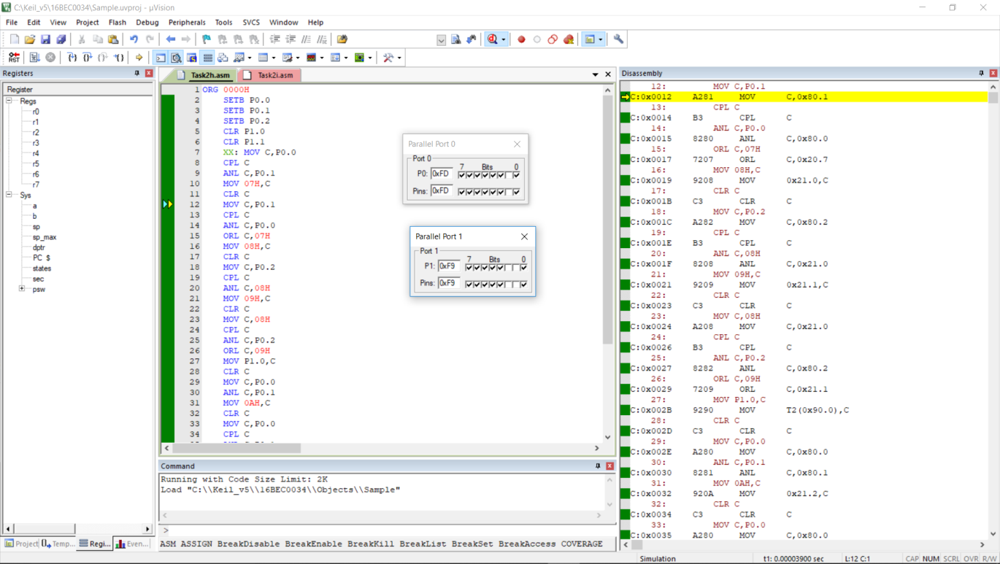

**6. x=1;y=0;z=1 so s=0 and c=1**

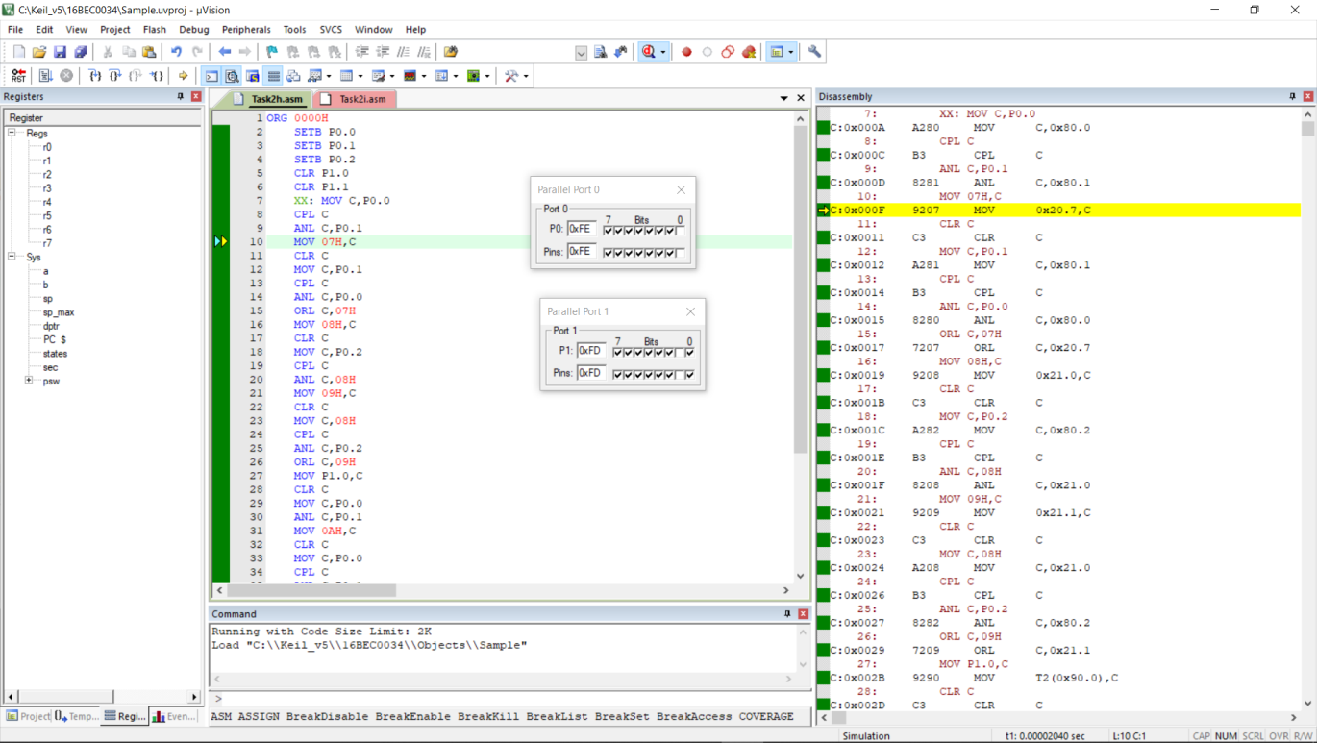

**7. x=1;y=1;z=0 so s=0 and c=1**

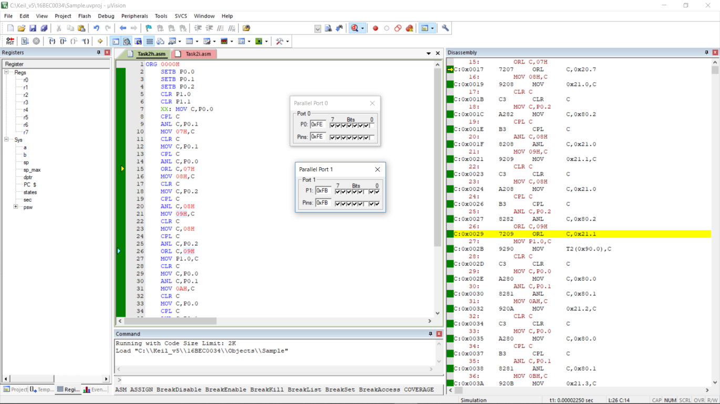

**8. x=1;y=1;z=1 so s=1 and c=1**

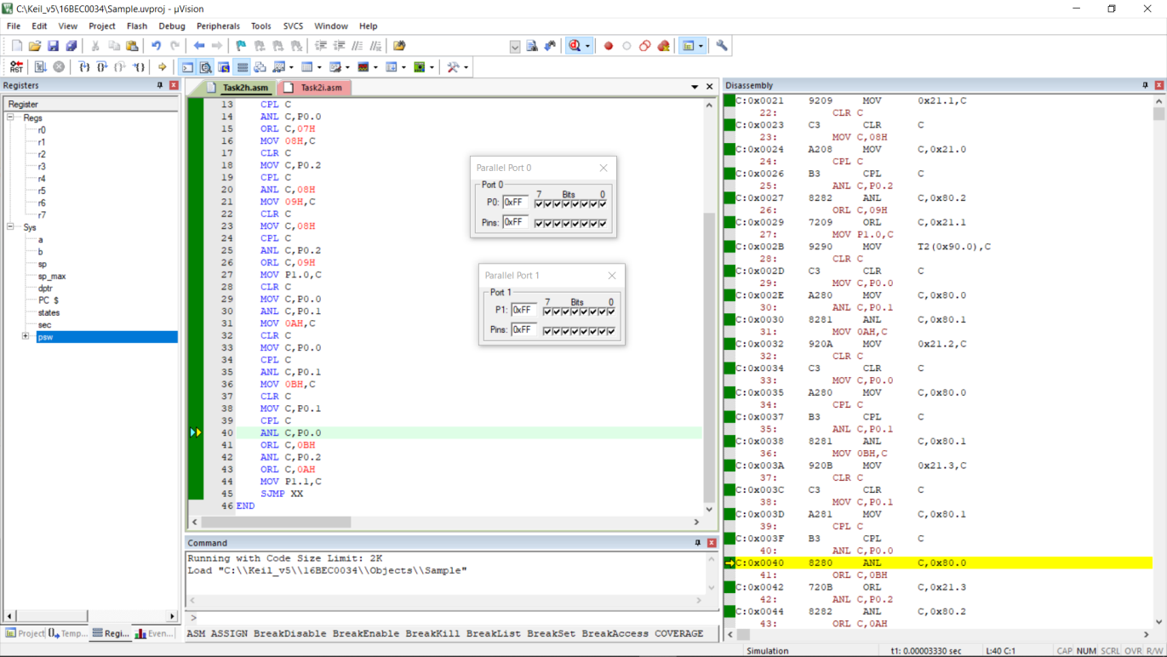

**Program 2c**

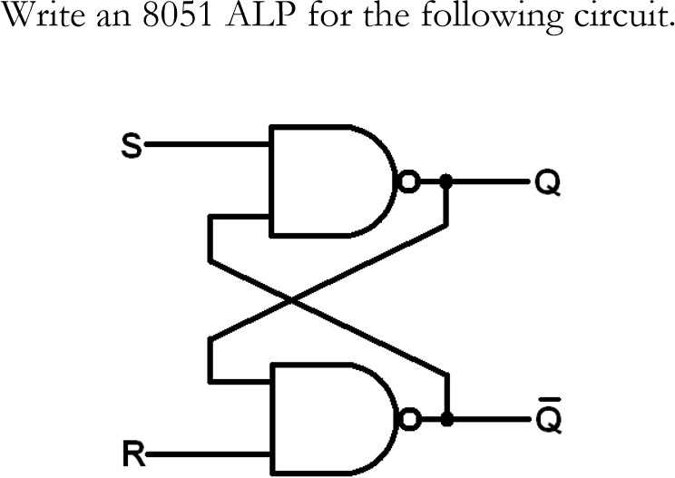

**Code:**

ORG 0000H

SETB P1.0

SETB P1.1

CLR P2.0

CLR P2.1

BACK: MOV C,P2.1

ANL C,P1.0

CPL C

MOV P2.0,C

MOV C,P2.0

ANL C,P1.1

CPL C

MOV P2.1,C

SJMP BACK

END

**OUTPUT:**

